

Middleton Parish Council
Minutes of meeting held Wednesday 8th April 2026 Middleton Village Hall, 6.30pm
Present:
Cllr J Beamish; Cllr G Keegan; Cllr G Hawkins; Cllr P Rotherham; Cllr M Watson (NWBC) Clerk: M Skinner
Apologies:
Cllr F Smith; Cllr S Green (WCC); Cllr S Smith (NWBC)

14/26 | Public Questions:  - Why is the promised hedge cut back on Crowberry Lane/Church Lane junction still outstanding despite requests and confirmation from HS2 this would be actioned? HS2 to respond as part of their April update?  - A4091, between Park Lane and Church Lane, leading to Middleton Hall, wire fence collecting rubbish; Cllr Hawkins has supplied images to Cllr Green for update  - Ford on Crowberry Lane has been cleared, silage apparent in stream. Cllr Green has confirmed no funding available to restore bridge structure. Wooden fence needs replacing and the metal rail is over 15 years old, consideration to replace these either from WCC funding or MPC grants | Cllr Green  Cllr Green  MPC
15/26 | Community updates:  None, however continued lack of presence from Community Police Support Officers was noted.
16/26 | Apologies for absence  Received from Cllr S Smith ; Cllr F Smith; Cllr S Green
17/26 | Declarations of Interest | None
18/26 | Minutes of previous meeting  Wednesday 11th Feb 2026, agreed and signed by Cllr Beamish as correct record of meeting | Cllr Beamish
19/26  19/26.1  19/26.2  19/26.3  19/26.4 | Matters arising: .  - A4091 – Cllr Green to advise when/if road improvement grants do become available for potential assistance with maintenance to alleviate flooding between Park Lane and Church Lane, however meeting agreed that Middleton Hall management should review potential obstructions which contribute to the flooding issue  - It was noted the NWBC planning portal has been redesigned, MPC will receive direct emails relating to planning applications within Middleton parish, portal is still available / weekly list search also available but show as PDF format.  - MCC – meeting discussed rent review due on the lease held by Tanner Holdings, Cllr Beamish to draft letter outlining the rent increase from 26th May, as per the agreement.  - Cllr Beamish raised concerns regarding parents parking across pavements whilst dancers are attending the Village Hall classes . to be raised with the VHC | Cllr S Green  Cllr Beamish  Cllr Beamish

20/26  20/26.1 | Key Financial Projects  - Quote received for additional fencing for VG gate end of pathway and wooden canopy structure over the new digital screen installation. Agreed £495 plus VAT
21/26  21/26.1  21/26.2  21/26.3 | New Actions:.  Current speed awareness cameras within Middleton to be moved further apart to make 20mph more visible , review current speed camera set up- OUTSTANDING  A4091 – Cllr Green to advise when/if road improvement grants do become available for potential assistance with maintenance to alleviate flooding between Park Lane and Church Lane, however meeting agreed that Middleton Hall management should review potential obstructions which contribute to the flooding issue - OUTSTANDING  HS2 Meeting; response from HS2 with be submitted during April 2026, - OUTSTANDING (appendix b) | Cllr Hawkins  Cllr Beamish  Cllr S Green
22/26  22/26.1  22/26/2  22/26.3  23/26 | Report from Councillors and Clerk:  Cllr Keegan - none  Cllr Beamish – none  Cllr Hawkins – none  Cllr Rotherham – none  Cllr Watson  - advised Garage Site, Church Lane, final decision notice to be made available and all relevant parties to be notified.  - Local development plan process in place, new sites to be identified, process as follows:  A Regulation 18 consultation is an early-stage, mandatory public consultation where local planning authorities invite feedback on draft policies and site options. Regulation 18 is the earlier, more informal "preparation" stage for gathering evidence and opinions, whereas Regulation 19 is the formal, pre-adoption, final draft consultation.  Plans to be submitted by end of 2026  - Richborough application (M42) refused but will appeal against decisions  - IM Properties application (M42) to be further reviewed given traffic management concerns, loss of greenbelt. Inspectorate to hear case June/July  - Budgets/Funding, for councillor grants available, in addition, funding available for community flagpole displaying the Union Flag  Clerk:  - Met with Reece Berry ( NWBC highways) for Middleton site visit relating to road signage which needs replacing due to damage/wear and tear. (appendix a)  - MSk confirmed first audit meeting as 24th April  - Easter Egg hunt successful despite the weather, plans for children’s activity day on VG during July  - Meeting agreed to purchase outdoor giant games for use at Fete and other community children’s events, allocated £1k .  Finance March 2026
March 2026 monthly financial report
Date | type | Detail | Amount | MCC | Precept
25/03/2026 |  | MCC rent | 2155.75 | 2155.75
TOTAL |  |  | 2155.75
PAYMENTS
Code | Payee | Description | INV | paid | Total
 | Tesco mobile | Feb charges | DD | 02-Mar-26 | 9.5
 | Rob Wilkes | balance payent for VG gates | inv | 17-Mar-26 | 2214
 | Easy Website | monthly web host fee | DD | 02-Mar-26 | 36.96
 | MPC Salary | Feb salary | DD | 09-Mar-26 | 686.63
 | HMRC | Feb tax | DD | 09-Mar-26 | 171.80
 | amazon | parts for screen installation | inv | 13-Mar-26 | 34.35
 | NWBC | Green bin renewal permit x 2 | DD | 19-Mar-26 | 90.00
 |  |  |  |  | 3,243.24
Balance at 28 Feb 26 |  |  |  |  | 4,421.46
Add receipts |  |  |  |  | 2,155.75
 |  |  |  |  | 6,577.21
Deduct Payments |  |  |  |  | 3,243.24
Total current account 30 Mar 2026 |  |  |  |  | 3,333.97
reserve account 30 Mar 26 |  | faw |  |  | 9,628.11
Events account 30 Mar 26 |  |  |  |  | 1,233.98
TOTAL Mar 2026 |  |  |  |  | 14,196.06
24/26 | Planning  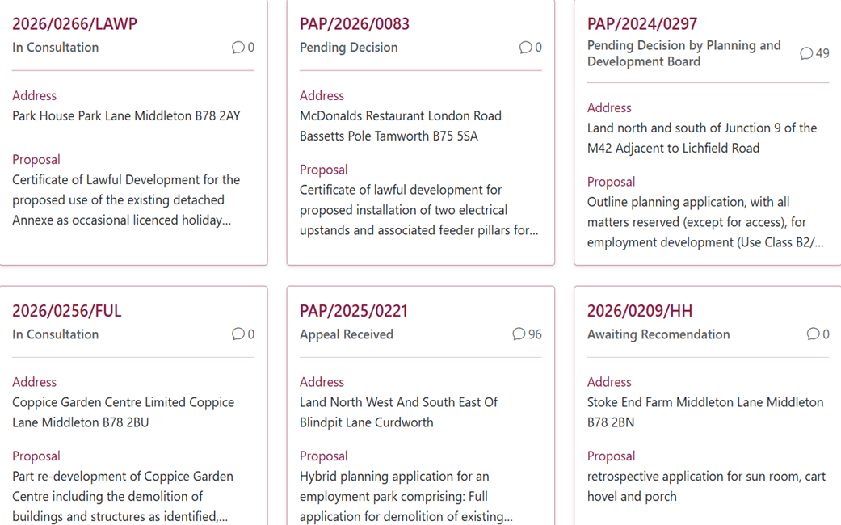  Meeting Closed: 20:15  Next Meeting :  13TH May – WPM MEETING  10th June – ANNUAL GENERAL MEETING followed by MPC meeting  8th July WPM MEETING  August NO MEETING  9TH September MPC MEETING  7TH October WPM MEETING  11TH November MPC MEETING  December NO MEETING  Signed:__________________________________________________________Date__________________
ITEM | ACTION | mBY WHOM

 | Cllr Beamish  Cllr Hawkins  Cllr Green  Cllr Beamish  Cllr Beamish  Cllr Keegan  M Sk
  11/26  11/26.1  11/26.3  19/26.3  19/26.4  21/26.3  22/26.3 | New Actions:.  Current speed awareness cameras within Middleton to be moved further apart to make 20mph more visible , review current speed camera set up  A4091 – Cllr Green to advise when/if road improvement grants do become available for potential assistance with maintenance to alleviate flooding between Park Lane and Church Lane, however meeting agreed that Middleton Hall management should review potential obstructions which contribute to the flooding issue  MCC – meeting discussed rent review due on the lease held by Tanner Holdings, Cllr Beamish to draft letter outlining the rent increase from 26th May, as per the agreement.  Cllr Beamish raised concerns regarding parents parking across pavements whilst dancers are attending the Village Hall classes . to be raised with the VHC  HS2 Meeting; response from HS2 with be submitted during April 2026, - OUTSTANDING (appendix b)  MSk confirmed Met with Reece Berry ( NWBC highways) for Middleton site visit relating to road signage which needs replacing due to damage/wear and tear. (appendix a)

Appendix A
Vicarage Hill
- Replace Middleton sign - Clean and reset roughly 30 days
- Replace 30mph sign – Clean and Reset roughly 30 days
- Replace warning horse sign – I do not have any notes to replace a horse warning sign?
- Replace hazard bend sign – Reset post and plates roughly 30 days
- Middleton Lane street sign – I will contact NWBC to arrange replacement and you confirmed that all street signs are the responsibility of NWBC
- Replace Middleton and Stoke/Allen End sign – I do not have any notes on this?
Middleton Lane
- Potholes identified throughout
- We also reviewed potholes outside of the Play Barn on the main road. As discussed, the repair may require a road closure, which would need to be coordinated with the proprietors of Ash End Farm. – Will be repaired all at once under TTRO and I will monitor for larger patching when budgets allow
Park Lane
- Two broken gully covers reported on 5 January remain outstanding. As noted yesterday, these present a hazard and require immediate attention. – Completed 20th March
- Potholes identified. – Early next week
Crowberry Lane / Park Lane junction
- Replace Middleton sign – replace post and plate roughly 6 months
- Replace Ford sign and add “Road Liable to Flooding” sign to the post – replace roughly 6 months
- Replace 30mph sign – I do not have notes for this
Crowberry Lane / Church Lane junction
- Replace Ford sign – Reset and clean initially roughly 30 days
- Replace signpost – Which signpost? I only have the 2x Ford sign for Crowberry Lane on my notes
- Replace “Road Liable to Flooding” sign – this is attached to the post with the Ford sign will be done together
Church Lane
- Replace “Middleton – Please Drive Carefully” sign and increase the height of the signpost where possible – discussing with Minor Works on whether we should adjust height/move the posts and plate elsewhere will raise works from their advice, roughly 6 months
Coppice Lane
- Replace “Middleton – Please Drive Carefully” sign and increase the height of the signpost where possible - discussing with Minor Works on whether we should adjust height/move the posts and plate elsewhere will raise works from their advice, roughly 6 months
- Replace “Reduce Speed Now” and warning sign – No notes on this, are these either side of the bend on Coppice Lane as you exit Middleton?
- The junction of Coppice Lane and London Road has been patched, however the repair is to an unacceptable standard and remains hazardous – temp repair completed , patching 92m2 is on the system, will be issued when budget is available
Road Markings
- Church Lane / Coppice Lane junction – road markings require refreshing. – I have the road markings on Church Lane, not Coppice Lane? If you could please let me know where I will take another look

Appendix B
- HS2 deferral notes and summary
- Health and Safety

There are ongoing concerns regarding partially completed work and unmaintained HS2 land during the deferral period as in

- unsecured sites, potential unauthorised access
- uneven surfaces, particularly with existing road surfaces
- debris,
- poor lighting
- mental anguish caused by the blight of which there is no end in sight.

all of which may pose hazards to residents, drivers and pedestrians.
- Road Safety

Within Middleton, road safety concerns specifically relate to

- altered road layouts and the overbridge which is now unmanned and could pose a security issue and be subject to vandalism,
- temporary traffic management measures have been left in place along Church Lane,
- damaged carriageways along Church Lane and Crowberry Lane due to the increased heavy vehicle movements associated with HS2 activity.
- The dangers of distraction of such a monostrosity overlooking a tiny village like Middleton
These issues heighten risks for motorists, cyclists, and pedestrians during the prolonged deferral period.
- Environmental Protection
On this topic, there are several concerns:
- overgrown hedgerows and unmanaged vegetation on HS2-owned land causing deterioration and negatively impact local amenities.
- The effect of loss of trees and hedgerows that were built by the parish and deleted from the village way ahead of time without any recourse for rebuilding.
- concerns regarding the loss of landscaping including the public walkway from the village green through to Drayton Bassett
- Assurances that all farmland and land affected by the HS2 disruption will be put back into productive use.
Regular maintenance, reinstatement of landscaping, and visual screening is required to alleviate these impacts.
- Civil Engineering and Technical Requirements

There is a need for regular inspection and maintenance of HS2-affected highways to address

- surface deterioration,
- drainage issues,
- road markings.
- The commitment for HS2-owned properties and assets which require ongoing upkeep to prevent structural decline, vandalism, and further blight to surrounding areas during the deferral period.
- In addition, there is a need to re-evaluate the ownership of these properties and for them to be put on the back on the market in a controlled manner.
5. Priority Level
High priority – due to the combined impacts on public safety, road user risk, environmental quality, and asset deterioration. Prolonged deferral without active management is likely to exacerbate risks and increase future remediation costs.

﻿

﻿

